Câu 2:

a, ${R=π}_{\left(SP.TenSP và SP.Gia\right)}(σ_{\left(\begin{aligned}SP.maSP=MB.maSP^ \\ NV.maNV=MB.maNV^ \\ KH.maKH=MB.maKH^ \\ SP.Loai="\text{VPP}\text{"} ^ \\ KH.DiaChi="\text{H}\text{ải}\text{ D}\text{ương" }^ \\ NV.TenNV="\text{Hương}\text{"}\end{aligned}\right)})(SP×KH×NV×MB)$

R=

$π_{\left(NV.tenNV\right)}(σ_{\begin{aligned}(KH.maKH=MB.maKH ^ \\ SP.maSP=MB.maSP {}_{}^{} \\ NV.maNV=MB.maNV {}_{}^{} \\ J_{\left(MB.maKH\right)}\left(COUNT\left(MB.maSP≥2\right)\right)\end{aligned}})(KH*NV×SP×MB)$

b, SELECT DISTINCT SP.TenSP, SP.Gia

FROM SanPham SP, KhachHang KH, NhanVien NV, MuaBan MB

WHERE SP.maSP = MB.maSP

AND NV.maNV = MB.maNV

AND KH.maKH = MB.maKH

AND SP.loaiSP = “VPP”

AND KH.DiaChi = “Hải Dương”

AND NV.tenNV = “Hương”;

SELECT DISTINCT NV.tenNV

FROM KhachHang KH, SanPham SP, NhanVien NV, MuaBan MB

WHERE KH.maKH=MB.maKH

AND SP.maSP=MB.maSP

AND NV.maNV=MB.maNV

GROUP BY MB.maKH

HAVING COUNT(MB.maSP)>=2;

Câu 3:

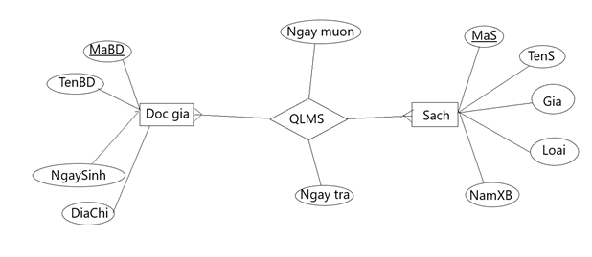

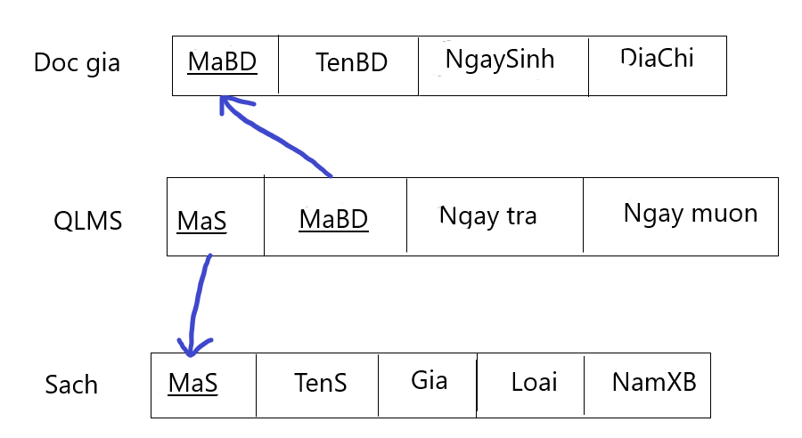

CREATE TABLE DocGia(

mabd CHAR(20),

tenbd CHAR(20),

ngaysinh DATE,

diachi CHAR(20),

PRIMARY KEY (mabd)

);

CREATE TABLE Sach(

mas CHAR(20),

tens CHAR(20),

loai CHAR(20),

gia INTEGER,

namxb INTEGER,

PRIMARY KEY (mas)

);

CREATE TABLE Reserves(

mabd CHAR(20),

mas CHAR(20),

ngaymuon DATE,

ngaytra DATE,

PRIMARY KEY (mabd, mas),

FOREIGN KEY (mabd) REFERENCES DocGia(mabd),

FOREIGN KEY (mas) REFERENCES Sach(mas)

);